Professional Responsibility
Nix v. Whiteside

Ineffective assistance of counsel:
• serious attorney error
• prejudice

What’s a lawyer supposed to do …

..“a wide range … acceptable under the Sixth Amendment”

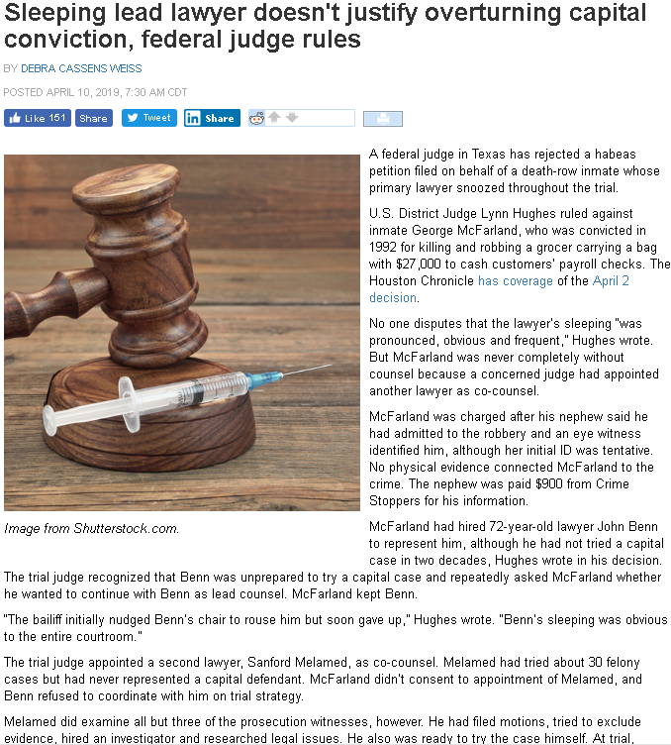

http://www.abajournal.com/news/article/sleeping-lead-lawyer-doesnt-justify-overturning-capital-conviction-federal-judge-rules/?utm_source=maestro&utm_medium=email&utm_campaign=weekly_email

Maxwell’s Silver Handled .38

Putting on a Good Face

Context can make things look entirely different:



Backlash on Lawyer’s Celebratory Comments

Robert L. McKenna III

Prosecutor's closing remarks about defense lawyers lead to new trial for murder defendant
BY DEBRA CASSENS WEISS
DECEMBER 6, 2019, 2:07 PM CST
A man who spent 13 years in a South Carolina prison for murder is entitled to a new trial because of the prosecutor’s “blatantly improper” remarks during closing arguments, the South Carolina Supreme Court has ruled.
The court overturned the conviction of Oscar Fortune in a Dec. 4 opinion, report the Legal Profession Blog, Bloomberg Law and the Associated Press.
Fortune had testified at trial that he fatally shot the victim in self-defense at a Huddle House parking lot in December 2001. He was convicted in 2006 and sentenced to 37 years in prison.
The prosecutor said in his closing argument that prosecutors have an obligation to prosecute when they think someone is guilty.
He went on to say: “My job is to show the truth. On the other hand, the defense attorneys’ jobs are to manipulate the truth. Their job is to shroud the truth. Their job is [to] confuse jurors. Their job is to do whatever they have to—without regard for the truth—to get a not guilty verdict.”
When the defense lawyer objected, the judge sustained the objection, saying, “I don’t think that their job is to defraud the court or the jury, and to that extent I sustain the objection.”
The defense lawyer had also objected to prior remarks by the prosecutor when he said the prosecutor has to “say what the truth is.”
The prosecutor’s argument violated Fortune’s due process rights, the South Carolina Supreme Court concluded.
Similar comments have been condemned by other courts, according to the state supreme court. “We find they were absolutely inexcusable.”

Who makes the rules?

Self-governing profession?

Sources:

U.S. Constitution

Courts: pursuant to their “inherent” powers

Ethics codes:
• Canons of Professional Ethics (1908)

• Code of Professional Responsibility (1970)
• Kutak Commission

• Model Rules of Professional Conduct (1983)
• Ethics 2000 Commission

Opinions of Bar Association “Ethics Committees”

General Law (common law and statute)
e.g., N.Y. Judiciary Law,

Restatement of the Law Governing Lawyers (1999)

Miscellaneous heuristic statements
• ABA Standards for Criminal Justice
• Lawyer’s Creed of Professionalism

“Real” Ethics (?)
Inherent Power of the Courts

● “positive” inherent power (to make rules)
● “negative” inherent power (no encroaching laws)
● legislative CLE requirement
● statutory limits on atty fees
● general law on deceptive trade practices

But..
● statutes ok that “reinforce” objectives of judiciary
● laws governing appointment and payment of
attys for indigents
● “some overlap” (Colo.) [= abrogation of inherent?]

Hot-button issue →
When Legislature tries to authorize practice of law

Judges s. Lawmakers (Problem 1)

Re: Problem re Guardianship CLE

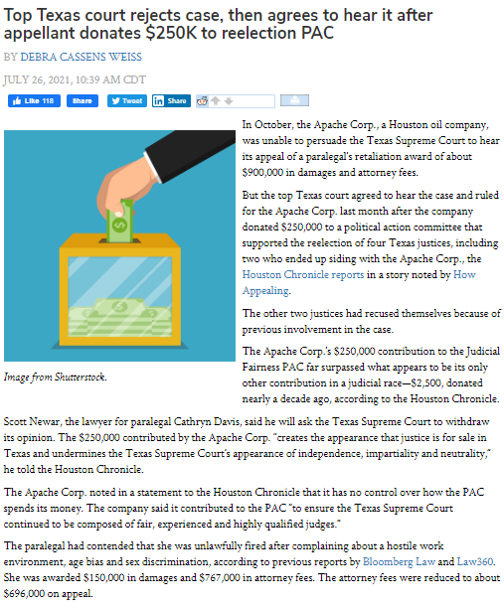

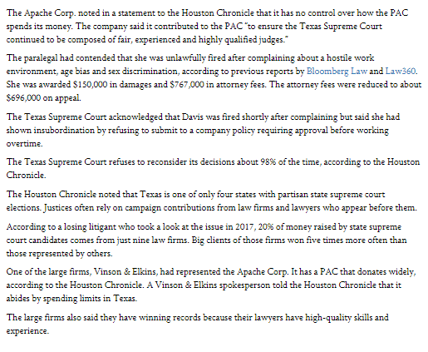

It’s said the practice of law is a “profession”
What is a “profession”??

• Specialized intellectual skills
• Extended training
• Particularized kind or level of trust—fiduciary
• “subordinates” self-interest and private gain
to the interests of clients or the public

• Roscoe Pound: in spirit of public service

• “Elite”?

(Commerce: “The best way to serve the common interest is by serving your own self-interest.”
Adam Smith

Fiduciary status –
..“unique position of trust and confidence”
• confidentiality
• loyalty
• no competing w/ client
• no obtaining of benefit at client’s expense
• ‘dealing’ with client?

Compare commerce: “arm’s length”

“Lawful” objectives of the client

Suppose your client’s objective is to:

• escape paying the damages he owes for the harm that he has unlawfully caused.
Say, for example, Harvey Weinstein is your client and he doesn’t want to pay his accusers.

• avoid paying damages for breach of a contract that has become burdensome.
“Get me out of this,” he says.

• keep her children in a divorce but she’s been in a relationship will count against her with the court (e.g., with a convicted drug dealer).

• wiggle out of the prison sentence that is prescribed by law for things he confidentially admits he’s done.

LOAN INFORMATION
PAST DUE AMOUNT – $845.32
CREDITOR – ACE CASH SERVICES

Dear Mr. _________:

You are going to be legally prosecuted in the Court House within couple of days. Your SSN is put on hold by US Government, so before something goes wrong we would like to notify you about this matter.
* * *
The Ethical Exploitation of the Unrepresented Consumer
Victoria J Haneman
University of La Verne College of Law
Missouri Law Review, Vol. 73, No. 707, 2008
Abstract:
This Article examines civil actions brought by attorney-represented debt buyers against unrepresented consumers, to collect debts against which the statute of limitations has already run. If the consumer were represented, an affirmative defense would be a complete bar to collection of the debt if it were raised, and malpractice on the part of the debtor’s attorney if it were not. The consumer debtor is almost always unrepresented and unlikely to raise this defense. The judgment of the court on a time-barred account starts the clock running anew on the debt instrument, and in effect blesses the exploitation of the debtor.
The Article examines the knowing exploitation of the unrepresented consumer by attorneys in the debt buying industry. It is not merely “ethically permissible” for an attorney to knowingly set this trap for the pro se defendant, doing so seems to be regarded positively, as an example of the duty of diligent or zealous representation. The adversarial process works because robust advocacy by the interests on opposing sides will illuminate for the neutral decision-maker the errors and excesses of each. The exploitation of the consumer debtor evidences one more practical setting in which core presumptions underlying this process fail – because one party is represented by counsel and the other is not.
This Article proposes narrowly-tailored regulatory and legislative solutions to curtail abuse of unrepresented consumers within this industry. The final solution is potentially broader in scope and consequence. While this Article does not propose the wholesale deconstruction of the adversarial system, in this instance when a core presumption has failed, it becomes necessary to police ethical boundaries of attorney conduct more closely. A proposed ethical rule entitled “Duty of Fairness Toward an Unrepresented Party Opponent” serves that purpose.
Keywords: unrepresented, statute of limitations, affirmative defense, debt
What is fair in negotiations?
● Anything goes
● Anything goes except outright lies
(affirmative misrepresentations)
● A sharing of all pertinent information
(no material non-representation allowed)

Purposes of Discipline
• to protect the public (“primary”) & admin of justice
• protect the integrity of the legal system
• deter further unethical conduct
• where appropriate, to rehabilitate the lawyer
• educate other lawyers and the public
But…“…not to impose sanctions for punishment”
ABA Standards for Imposing Lawyer Sanctions, commentary

Sanctions
• disbarment (indefinite or permanent)
•suspension
• censure (public reprimand)
• private censure
• various warnings, admonitions, cautions, etc.
• (more recent): force L to attend classes on legal ethics

Basic “due process” requirements
• notice
• opportunity to be heard

..burden of proof

Reading # 2

Elements of the Client-Lawyer Relationship: Competence

Basic skills are all lawyers expected to have:
• analysis of precedent
• evaluation of evidence
• legal drafting
• recognition of legal problems
Model Rule 1.1 Comment 2

The little nuances of legal doctrine are among the most important tools that lawyers use to help their clients achieve their goals. To be ready to help real people, lawyers must able to skillfully manage technical concepts.
Neglect:

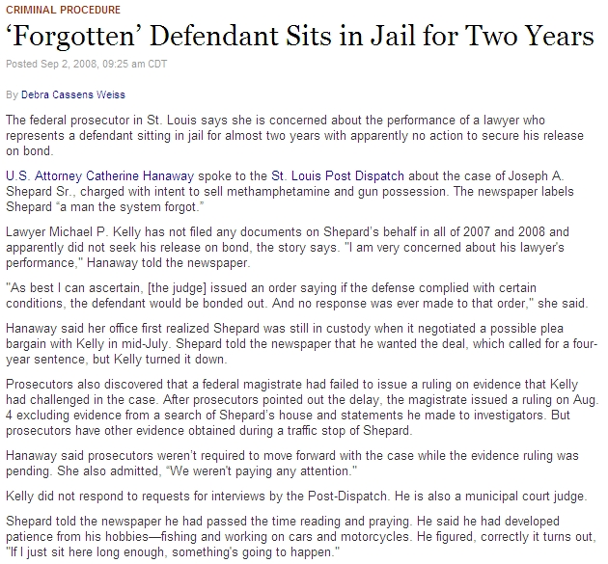

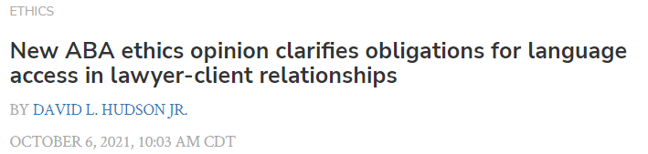

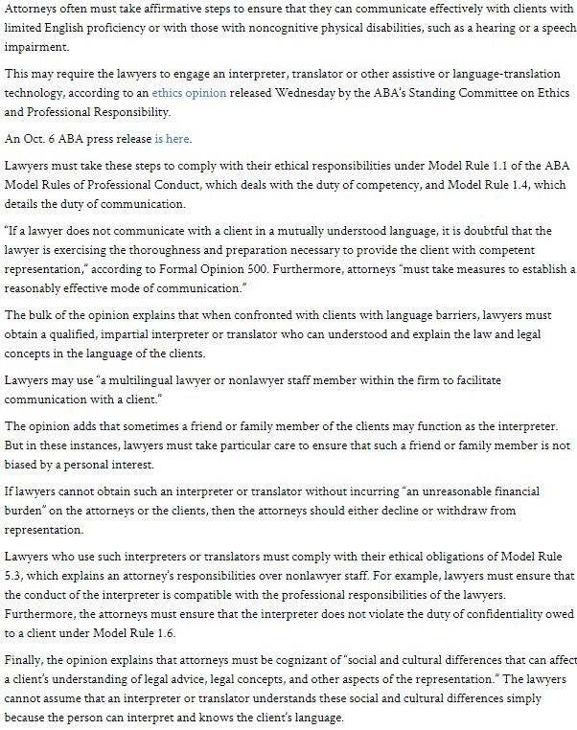
Rule 5.1:

Partners (or comparable managerial authority):

● reasonable efforts

● firm has measures

● reasonable assurance

.. that all lawyers in firm conform to the Rules

Also:

Direct supervisory authority:

Reasonable efforts to ensure conformity

Also:
Any “partner” or direct supervisory who knows…
→ must take “reasonable remedial measures”

Finally, any lawyer who:
● orders
● ratifies
…conduct in violation of the Rules

EC 9.1 & 9.2

Avoiding Appearance of impropriety

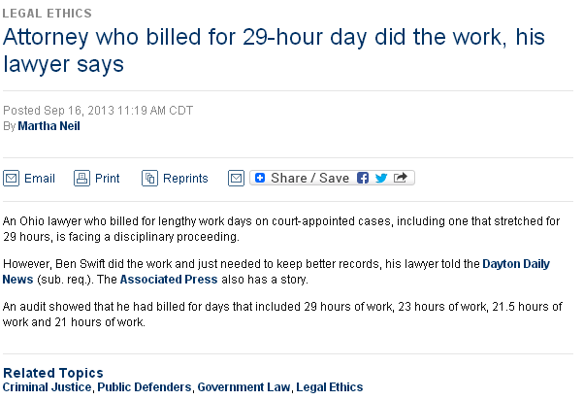

http://www.abajournal.com/news/article/attorney_who_billed_for_29-hour_day_did_the_work_his_lawyer_says/?utm_medium=email&utm_campaign=weekly_email&utm_source=maestro&sc_cid=130918AL

Reading # 3
Elements of the Client-Lawyer Relationship: Agency

As between lawyer and client,
who is supposed to decide on:

• Objectives

• Means

Who has the final right to decide on:
● settlement
● acceptance of plea deal (criminal)
● jury trial (criminal)
● whether client will testify (criminal)

Binding the client:

• Actual authority
• Express
• Implied
• Inherent (implied by R-ship)

• Apparent Authority (= estoppel)

power vs. right

Vicarious admissions:
• general (non-hearsay, but rebuttable)
• statements “in court or in pleadings”
Blunders:

Who has responsibility for assuring justice if a lawyer sees that the adversary’s lawyer:

• Leaves out a key clause of a contract?

• Misunderstands critical date (S/L)?

• Has obviously overlooked a critical piece of evid?
• Has omitted to ask W a critical question?

• Other L doesn’t object to inadmissible evidence?

• Ok to object to admissible evidence?

Blunders at Trial:
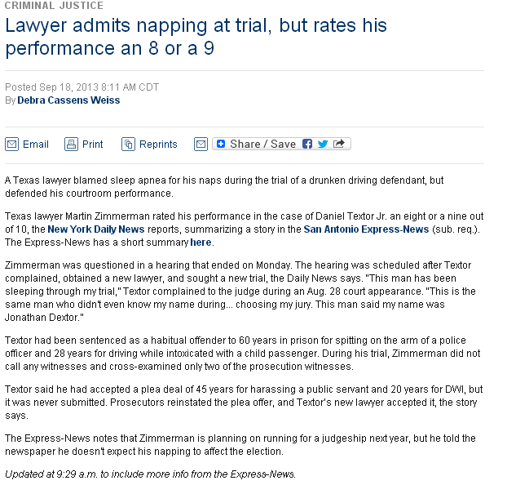



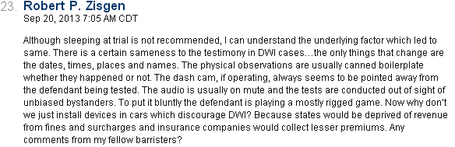

http://www.abajournal.com/news/article/lawyer_admits_napping_at_trial_but_rates_his_performance_an_8_or_a_9

Fiduciary status –
..“unique position of trust and confidence”
• confidentiality
• loyalty
• no competing w/ client
• no obtaining of benefit at client’s expense
• ‘dealing’ with client?

Procedural Defaults

• Taylor v. Illinois

• Bakery Machinery & Fabrication v.
Traditional Baking, Inc.

• Cotto v. United States

What’s our goal here?
● make sure people get a fair shake
● to correctly assign “blame” if things go wrong

Bakery Machinery case:

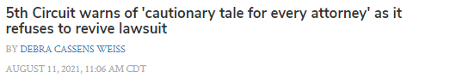

A federal appeals court has refused to reinstate a lawsuit tossed after the plaintiff’s lawyer didn’t see a filtered email notice and didn’t respond to a motion for summary judgment.

The 5th U.S. Circuit Court of Appeals at New Orleans called the case “a cautionary tale for every attorney who litigates in the era of e-filing.”

Law360 and Bloomberg Law have coverage of the Aug. 9 opinion, written by Judge James Ho.

The lawyer didn’t see any notice of the May 7, 2020, summary judgment motion because his email system sent it to a folder labeled “other.” All prior case filings had gone to his firm’s main email box.

The lawyer represented Kevin Rollins, who was suing his employer, the Home Depot, for injuries that he received while moving a bathtub. The case was filed in state court and then removed to federal court. The lawyer, Aaron Allison of Austin, Texas, agreed to receive filings through the court’s e-filing system.

Allison did not learn of the pending motion when he contacted the Home Depot attorney to discuss settlement a few days later.

The district court tossed the case after Allison failed to respond to the summary judgment motion in 14 days, the deadline to file and serve responses to any motions. Allison learned of the disposition when he contacted the Home Depot attorney again June 3 to discuss a settlement.

Allison sought relief from the judgment under Rule 59(e) of the Federal Rules of Federal Procedure. On appeal, he argued that failure to grant the motion was an abuse of discretion, and that a factual dispute bars summary judgment. He lost on both arguments.

“To be sure, we do not question the good faith of Rollins’ counsel,” the appeals court said.

But the appeals court said precedent prevents Rule 59(e) relief in such circumstances. The court cited Trevino v. City of Fort Worth, a 2019 5th Circuit case in which a lawyer’s defective antivirus software diverted court emails to a spam folder. The 5th Circuit ruled against that lawyer, who had failed to respond to a motion to dismiss.

In the Home Depot case, the 5th Circuit said Allison “was plainly in the best position to ensure that his own email was working properly—certainly more so than either the district court or Home Depot. Moreover, Rollins’ counsel could have checked the docket after the agreed deadline for dispositive motions had already passed.”

The appeals court also said Allison did not raise his argument about the factual dispute in his initial motion to reopen the judgment, and the argument is waived.

Allison told the ABA Journal that he is disappointed by the ruling.

“I think that the rules of procedure and electronic filing need to be changed,” he says.

Allison had argued that the 5th Circuit should carve out an exception to the holding in Trevino, which involved a law firm that was aware that its antiviral software was causing lawyers to miss critical filings and pleadings.

Allison says his firm had never had a problem with e-filing or with the email system. The opposing counsel never separately notified Allison of the filing and continued settlement talks with the apparent knowledge that Allison wasn’t aware of the pending motion, Allison says.

After Allison learned of the granted summary judgment motion, his firm checked and scanned all emails and found the motion in an “obscure part” of the email system, he says. The firm tried to open the email, but it had been corrupted.

Allison says that, in his opinion, the 5th Circuit’s “lawyer beware” decision implies that e-filing lawyers will have to check the docket by the dispositive motion deadline and will have to make sure motions have been filed.

Allison is conferring with his client on whether to file a motion for reconsideration en banc, and if that is denied, a cert petition to the U.S. Supreme Court.

What’s our goal here?
● make sure people get a fair shake
● to correctly assign “blame” if things go wrong

On other hand, there’s an inherent conflict between
● trying to regulate lawyer conduct
● autonomy required by adversary system

Problem with “autonomy” argument:
● Few people get involved with the system
in a truly voluntary “autonomous” way

● Those who do are essentially at the mercy of
the system’s functionaries (i.e., the lawyers)

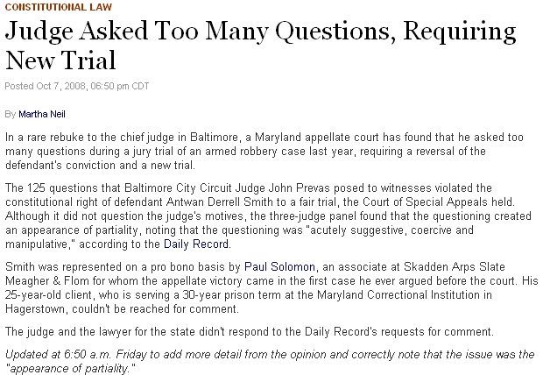

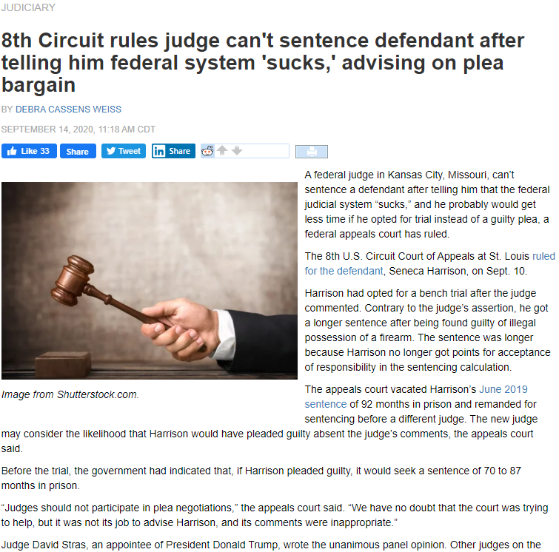

https://www.abajournal.com/news/article/judge-cant-sentence-defendant-after-telling-him-federal-system-sucks-advising-on-plea-bargain
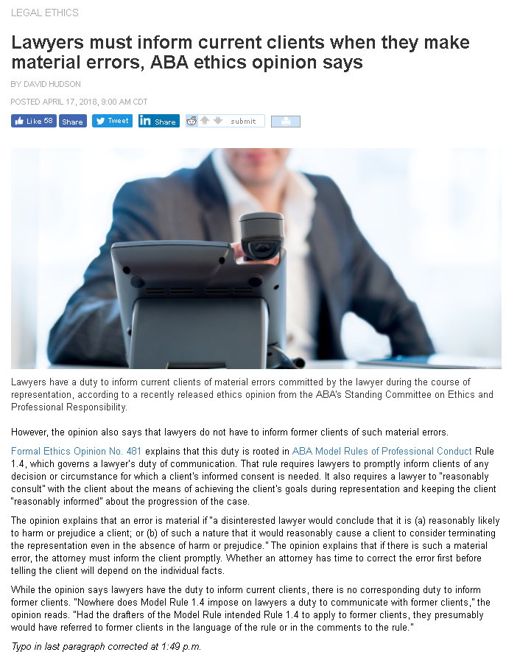

http://www.abajournal.com/news/article/lawyers_must_inform_current_clients_of_material_errors/?utm_source=maestro&utm_medium=email&utm_campaign=weekly_email
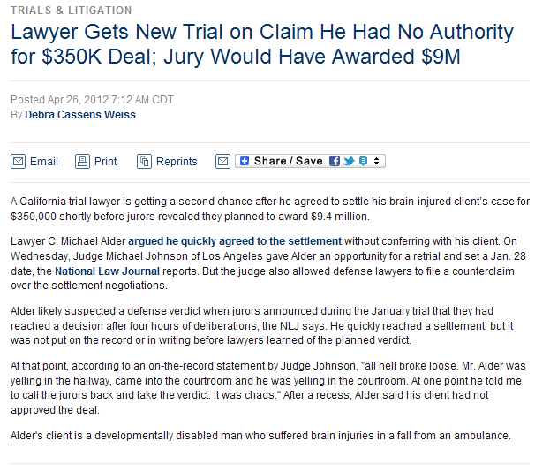

http://www.abajournal.com/news/article/lawyer_gets_new_trial_on_claim_he_had_no_authority_for_350k_deal_jury_would/?utm_source=maestro&utm_medium=email&utm_campaign=weekly_email

In a Box:

Zagott Chin

↓ ↓

Marsh Font & Blue

Reading # 4
Elements of the Client-Lawyer Relationship: Loyalty

Model Code:
A lawyer should represent the client zealously

Model Rules “reasonable diligence” →
• “whatever lawful and ethical measures are required to vindicate a client’s cause or endeavor”

• “act with commitment and dedication to the interests of the client”

• “zeal in advocacy” on the client’s behalf

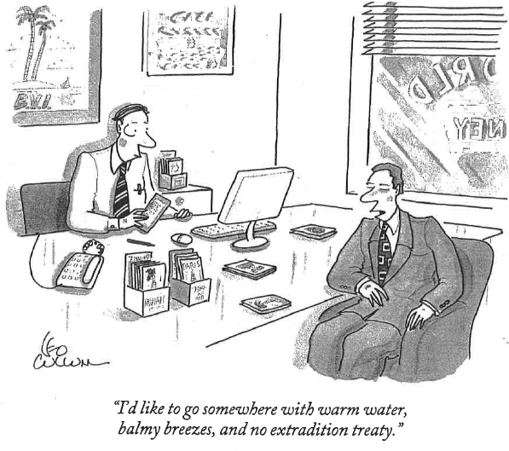
Rule 1.2(d):

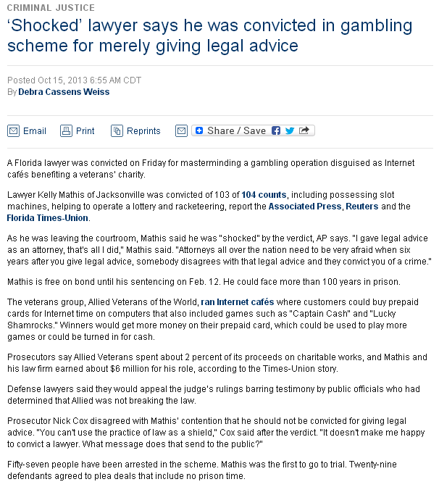

http://www.abajournal.com/news/article/shocked_lawyer_says_he_was_convicted_in_gambling_scheme_for_merely_giving_l/?utm_campaign=weekly_email&utm_source=maestro&utm_medium=email&sc_cid=131016Z
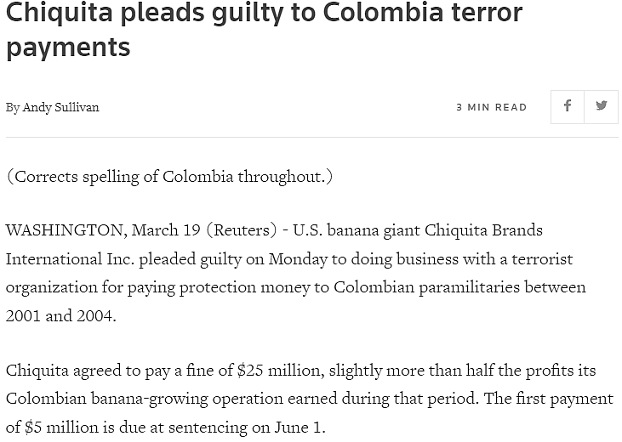

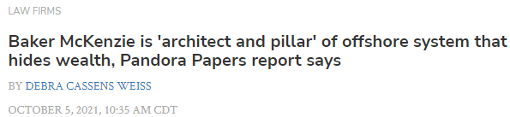
Baker McKenzie fought proposals to strengthen financial oversight and tax laws in its lobbying for large banks and technology companies, according to Pandora Papers reporting by the International Consortium of Investigative Journalists and its media papers.
The law firm has lobbied for dozens of corporations and defended them when challenged by authorities, according to an ICIJ story noted by Law.com. It has also advised dozens of large companies on tax or offshore maneuvers.
“Baker McKenzie is an architect and pillar of a shadow economy, often called ‘offshore,’ that benefits the wealthy at the expense of nations’ treasuries and ordinary citizens’ wallets,” the ICIJ report says.
“Baker McKenzie has helped multinationals and the wealthy avoid taxes and scrutiny through the use of shell companies, trusts and complex structures in tax havens. These vehicles, shrouded in secrecy, hold vast riches—homes, yachts, stock and money that is sometimes of murky origin.”
The story is part of a series of reports in which the ICIJ is highlighting revelations contained in 11.9 million documents leaked from 14 companies in the offshore financial services industry, according to a description by the New York Times.
Baker McKenzie documents are not among the leaked files, but the law firm is mentioned in more than 7,500 documents, according to the ICIJ.
The leaked documents are dubbed the Pandora Papers, after the Greek myth in which Pandora, the first human woman created, opened a jar containing the world’s evils.
“When billionaires, multinationals and the politically connected seek to hide wealth or avoid taxes, they often turn to Baker McKenzie,” the ICIJ story says. The law firm’s clients include “people and companies connected to political corruption, fraudulent business practices and authoritarian regimes.”
Among the clients of Baker McKenzie and its affiliates:
• Jho Low, who is now accused of masterminding a scheme to embezzle billions of dollars from the 1MDB investment fund.
• Ukrainian oligarch Ihor Kolomoisky, accused of using shell companies in a $5.5 billion money laundering scheme.
Baker McKenzie defended its work in a statement cited by Law.com.
“Like other law firms and relevant industry or subject matter experts, Baker McKenzie is regularly requested to assist governments and regulatory bodies with the analysis and development of potential new legislation in countries around the world by contributing our legal expertise and experience,” the firm said.
“We are also asked by clients to provide expert input on proposed laws and regulations, including through public submissions processes or occasionally by legislative testimony. All our work in this area is done in compliance with applicable laws and regulations, including lobbyist registrations where required.”
The firm also noted that taxation “is a core area of our global expertise. Our advice is always in strict accordance with all applicable laws and regulations. Transparency and accountability are integral elements of such advice and we strive to ensure that our clients adhere to both the law and best practice.”
Law360 gathered reactions to the Pandora Papers in stories here and here.
Tax experts said many of the wealth-hiding mechanisms described in the Pandora Papers are entirely legal.
Ian Gary, executive director of the Financial Accountability and Corporate Transparency Coalition, saw the need for reform.
“The revelations of the Pandora Papers show that the Panama Papers were not a one-off example of a rogue law firm but just the tip of the financial secrecy iceberg and the massive corruption it hides,” Gary told Law360.
Another Law360 report cited calls for new rules to combat money laundering. The story noted a new measure, the Corporate Transparency Act, that will help combat financial secrecy. The law is part of the Anti-Money Laundering Act of 2020, which was part of the National defense Authorization Act for fiscal year 2021.
The Pandora Papers report “are yet another reason, as if we needed one, why the U.S. Treasury needs to move quickly to implement regulations under the Corporate Transparency Act,” said Ross Delston, a lawyer specializing in anti-money laundering issues, in an email to Law360.
But Peter Hardy, the founder of Ballard Spahr’s anti-money laundering team, told Law360 that he doubts that the Corporate Transparency Act or a new customer due diligence rule for financial institutions would stop money laundering by the ultrarich. Neither, he said, addresses trust vehicles that aren’t created through a public filing.
“It’s far from clear that FinCEN’s forthcoming CTA regulations will be able to even address this particularly thorny problem,” Hardy said.

Withdrawal and Noisy Withdrawal:

ABA Opinion 366

MR 1.16(a) – “shall” withdraw if “representation” →
violation of … law
MR 1.2(d) – shall not “assist” C in crime/fraud
MR 1.6 – duty to maintain confidentiality

Since lawyer:
• invited the other side’s reliance on her opinion
• knows C intends to use the opinion in future fraud
→ required to disaffirm the opinion
• may be “nec’y to make the withdrawal effective”

As for MR 1.6:
“compliance with 1.16(a)(1) and 1.2(d) appears [to]
have collateral consequence of disclosing confidences”

Finally:
• disavowal may be nec’y accompaniment to withdrawal
(if L expects continuing or future use for fr/crime)
• this “noisy withdrawal” is lmtd to “where mandatory”
• doesn’t matter who (L or C) terminates Rship

=========
Portion of logic that dissent most disagreed with:
• an “old” opinion = (current) “representation”
• allowing C to use it = to “assist”
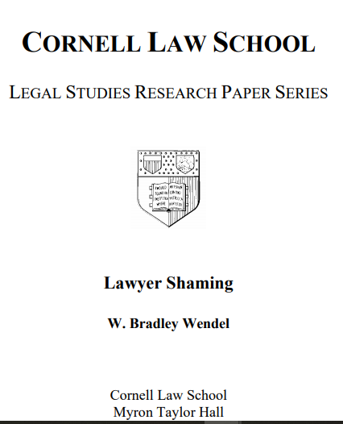
Jones v. Barnes
[6th amd. rights to effective assistance of counsel]

Governmental Interests in Conflict:
• State’s interest in substantive justice
• protect dignity and autonomy of accused
(presumed innocent until conviction?)

Brennen & Marshall:
• lawyer’s job = “assisting the client, not making choices for him”

• indigents often mistrust the system and the “lawyers appointed to them”

• to force appointed lawyer’s decisions on client supports belief that “law conspires against them”

Majority:
• undermine ability of counsel to present case in accord w/ counsel’s professional evaluation

• winnowing out weaker arguments avoids dilution & depreciation of argument

Who do you think has the better argument?
How fees are in structural conflict w/ client interests
(not just a “burden” for the client)

Fees can directly influence how lawyer behaves
• reject settlements the client may want
• accept settlements the client may not want
• spend time pursuing claims that lack merit
• barrier to settlement
• barrier to getting in court at all

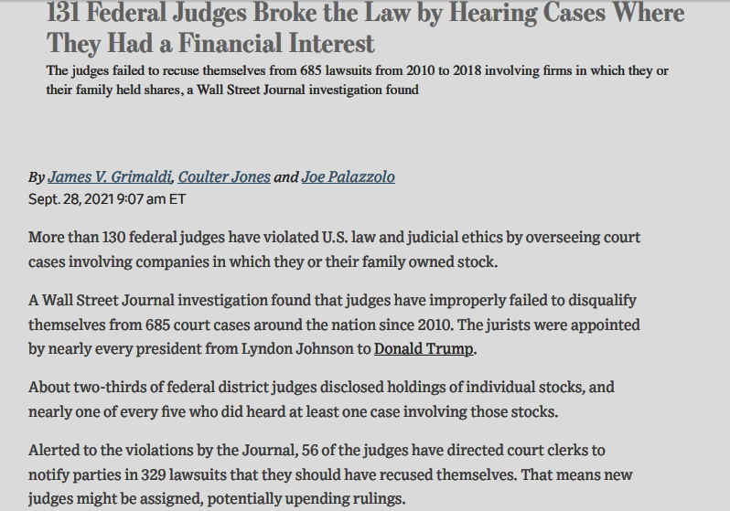

Frivolous claims:


