“[N]or shall private property be taken for public use, without just compensation.”

U.S. Const amend. V.

Taking
• Physical Invasion (“inverse condemnation”)
• Land Use Regulation under the Police Power
(health, safety, morals and welfare)

Early attempts to understand validity of regulation:
Nuisance (public, private) → harm/benefit “rule”

Adjusting the benefits and burdens
of economic life

Average reciprocity of advantage

Navigation exception

Can property rights be changed to meet new conditions?

Property Protection (constitutional)
● Contract clause – not impair obligation of K
● Due process clauses
● Takings clause

* * *
I. Contract clause –
The “reservation of the reasonable exercise of the protective power of the States is read into all contracts.”
Home Building & Loan Ass'n v. Blaisdell.
* * *
II. Due Process clause –
No person shall be “deprived of life, liberty or property without due process of law.”

● “Economic” due process:
● needs of public require the interference
● reasonable nec’y to meet the need
● not unduly harsh or burdensome
Lawton v. Steele (1894)
● “Rational Basis” test
* * *

III. Takings Clause →

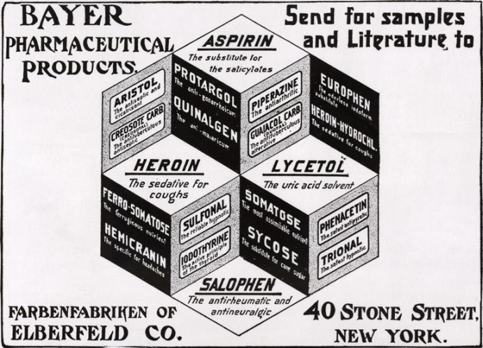
Lead-up to Lucas:

Pumpelly v. Green Bay (1871)

Mugler v. Kansas (1887)

Pennsylvania Coal Co. v. Mahon (1922)

[over 50 years…]

● Three-part test of “too far”:
● economic impact
● reasonable investment-backed expectations
● “character” of the interference
Penn Central. v. New York City (1978)

But … “no set formula”
Lucas:

● the law is valid as a harm prevention measure
● the law is invalid → takes all econ beneficial use

Lucas:
“[G]overnment may affect property values by regulation without incurring an obligation to compensate—a reality we nowadays acknowledge explicitly.”

Exceptions:
● physical invasion
● removal of “all value”

Exception to the “all value” exception:
● if a right to engage in the regulated
activity wasn’t part of the property to begin with: ● public right of navigation
● nuisance
●private nuisance
● harm caused by D’s acts
● social value of D’s acts
● ease of avoiding harm
● public nuisance
…public health, safety, morals, & welfare

Qualifications:
● anti-segmentation rule
● investment-backed expectations(?)
Property rights against the
Regulatory State (summary):

● there are 3 constitutional provisions
thought to protect private property:
● Contract clause
● Due process clauses
● Takings clause

● Two of them: almost totally eviscerated
by “rational basis” test
● a matter of limiting judicial review
● “who decides” policy?” = the Legislature

● Takings clause still operates full-force
.. but only in cases of actual physical takings

Civil forfeiture:

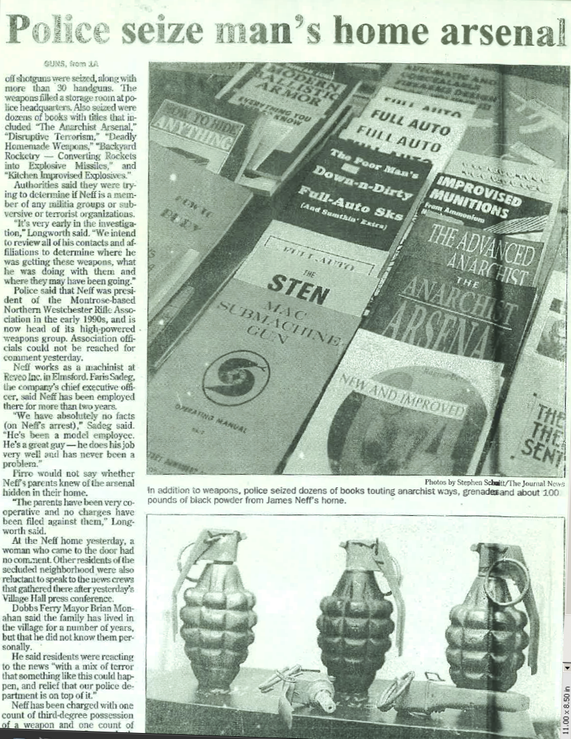
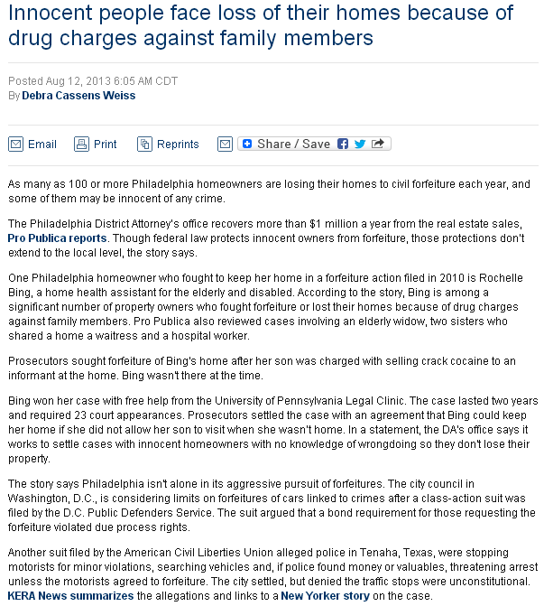

US Customs seizes Ohio family's life savings at airport
By Kelly Murray, CNN
Updated 10:59 AM ET, Mon June 4, 2018

Son: Money was always saved for family's future 01:26


(CNN)Members of an immigrant family in Ohio say US Customs and Border Protection seized $58,100 of their life savings. Now they want it back.
Rustem Kazazi, 64, was headed to his native Albania to visit relatives in October, according to a federal lawsuit that he, his wife, Lejla, and son, Erald, filed this week in Ohio against the agency and others.
The suit alleges Customs and Border Protection used civil forfeiture laws to take the money without arresting or charging anyone with a crime.
Kazazi had planned to spend six months in Albania and buy a vacation home for retirement on the Adriatic coast, according to court documents. He also wanted to help members of his extended family, who are struggling, the court documents said.
To make the transactions easier and avoid bank fees, he reduced his family's life savings to cash, packed it in a carry-on and brought it with him to the airport, according to the family's lawsuit.
https://www.cnn.com/2018/06/02/us/ohio-us-customs-cash-taken/index.html

CIVIL ASSET FORFEITURE

DEA Seizes Life Savings of New Orleans Grandfather without Charging Him with a Crime

The case is the latest example of people who say their savings were seized in airports, despite it being perfectly legal to fly domestically with large amounts of cash.
C.J. CIARAMELLA | 8.17.2021 4:07 PM


Kermit Warren (Institute for Justice)

A New Orleans grandfather says the Drug Enforcement Administration (DEA) took his life savings based on flimsy accusations of drug trafficking and without ever charging him with a crime. Now he's fighting to get it back.

Police Ripped Off More Stuff Than Burglars Did Last Year
Civil asset forfeiture is big business for cops.
By Phillip Smith / AlterNet
November 27, 2015
When you think about getting property stolen, you think about criminals, but maybe you should be thinking about the police. Law enforcement use of asset forfeiture laws to seize property—often without a criminal conviction or even an arrest—has gone through the roof in recent years, and now the cops are giving the criminals a run for their money, and winning.
According to a new report on asset forfeiture from the Institute for Justice, police seized $4.5 billion in cash and property through civil forfeiture last year. That exceeds the $3.9 billion worth of property stolen in burglaries during the same period. The valuation of burglary proceeds is from the FBI's annualUniform Crime Report.
Now, not every dollar seized by police is stolen. Some of it is seized legitimately from real criminals who should pay for the damage their crimes cause. But in too many cases, property is seized from people who have not been convicted of anything.
Take Charles Clarke. Clarke, a 24-year-old college student, was relieved of $11,000 in cash by federal agents at the Cincinnati/Northern Kentucky International Airport after a ticket agent reportedly told them he smelled like marijuana. They stopped and searched him at the airport, found no drugs or other banned items and never charged him with a crime, but they took his money.

Pa. Supreme Court makes it harder for the D.A. to seize your home
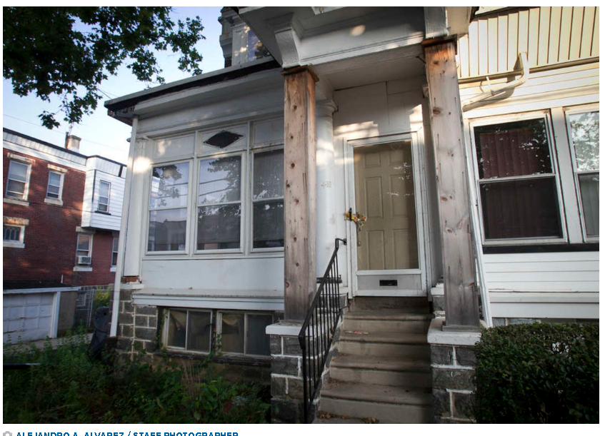

Updated: MAY 26, 2017 — 4:05 PM EDT
by Chris Mondics, Staff Writer @cmondics | cmondics@phillynews.com
In a decision that strengthens the hands of homeowners swept up in civil forfeiture actions, the Pennsylvania Supreme Court ruled that authorities must have strong evidence showing a home or car was used in a crime and that the owner consented to the illegal activity before they move to seize the property.
In a unanimous, 73-page opinion, the court found that although authorities have the right to seize property used in illegal enterprises, they must prove that the owner not only was aware of the illegal activity but also had agreed to it. The court also found that property seizures may breach the Eighth Amendment’s prohibition against excessive fines if the seizure is “grossly disproportional” to the underlying offense.
http://www.philly.com/philly/business/law/pa-supreme-court-makes-it-harder-for-the-d-a-to-seize-your-home-20170526.html?mobi=true

Using loophole, Seward County seizes millions from motorists without convicting them of crimes
One of every three state civil asset forfeiture seizures happen in this county, pop. 17,962
June 16, 2023 2:07 pm

SEWARD, Neb. (Flatwater Free Press, Natalia Alamdari) – Four hundred and fifty-five miles of Interstate 80 run through Nebraska.
But one 24-mile stretch has become nationally known – or notorious – for a type of traffic stop that sends millions to a single Nebraska county and its sheriff’s office.
In August 2020, flashing police lights stopped Christopher Bouldin’s van on this short ribbon of road as he headed west through Seward County.
Within minutes, Bouldin found himself standing with his dog on the westbound shoulder.
Seward County deputies had just found $18,000 in cash rolled up in a blue sleeping bag in his backseat. It’s drug money, they alleged. It’s money for my trip to Colorado, Bouldin responded.
There, on the side of the road, 1,300 miles from his Virginia home, in a state where Bouldin knew no one, a sheriff’s deputy handed him a form.
You can sign this piece of paper, abandon the $18,000, avoid arrest and continue on to Colorado, he says he was told.
Don’t sign, and you will go to jail. You could face felony charges. Your van will be towed. Your dog will be taken to the pound.
“They were trying really hard for me to sign that,” Bouldin said.
Traffic stops like these, where passing motorists are pulled over, searched and asked to turn over any cash that’s found, are big business in Seward County, population 17,692.
Here, money is routinely seized without anyone being charged or proven guilty of anything.
Kelo v. City of New London:

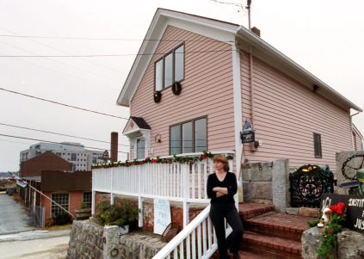

Ten years later:
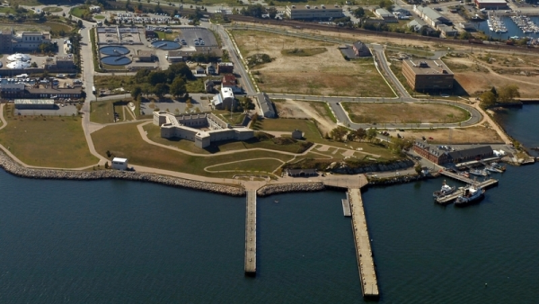

Taking
• Physical Invasion (“inverse condemnation”)
• Land use regulation
• "too far"
• "all economic or beneficial use"

But … Police Power
(health, safety, morals and welfare)

Nuisance (public, private)
● harm/benefit “rule”

Adjusting the benefits and burdens
of economic life

Average reciprocity of advantage

Navigation exception

Takings summary:

● Permanent physical invasions always
require compensation

● “Regulatory” impingements almost never
require compensation
● Exception: Total takings” (extremely rare).

● Exception: “not part of title to begin with”

● Lucas still has tremendous indirect influence

● Civil forfeiture is an irreconcilable exception

